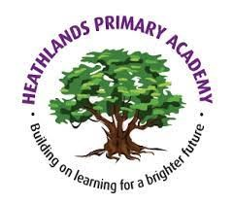
Useful websites
· www.phonicsplay.co.uk
· www.primaryresources.co.uk
· Phonics RWI: https://www.ruthmiskin.com/en/find-out-more/parents/
· Youtube: Days of the week song, Months of the year song, Big Numbers song, I can count to 100 song, seasons of the year song, 2D & 3D shape song.

Summer 1:
The Sea

A note from Reception Staff
We are so excited to start our new topic ‘The Sea.’
PE lessons will take place every Thursday and we ask that children are sent to school wearing their PE kits on these days. We thank you in advance for your support so far.
We will continue to communicate through the ‘Seesaw’ App which you should have received the log in details for at parents evening.
Best wishes, Reception Team
Theme for Summer 1
This terms topic is ‘The Sea.’ We will be learning about sea creatures, pirates and mermaids

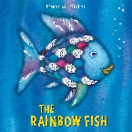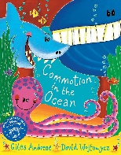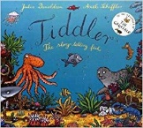

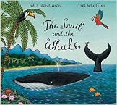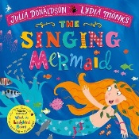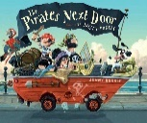

How can you help me to carry on learning at home?
The value we are focusing on this term is ‘responsibility.’ Responsibility is about doing the things we are supposed to do and accepting the positive or negative outcomes of our actions.
A responsibility: something you are expected to do
Being responsible: doing the things you are supposed to do.
Accepting responsibility: taking the praise or the blame for something you have done.

Reminder: Please ensure your child comes to school with a water bottle that is clearly labelled with their name and that all clothing is clearly labelled. Please also ensure that your child has a clean set of spare clothes that we can leave on their peg all year in the event of their clothes becoming wet/soiled – Thanks.

Understanding the World
In Understanding of the World, we will learn about floating and sinking. We will be observing sea creatures and their habitats. We will also explore how to use technology to complete simple programmes.

Personal, Social & Emotional Development:
This term our PSED topic is ‘relationships’. We will work through this topic using our Jigsaw programme. We will learn to:
· Share, take-turns and show good friendship.
· We will work on building our confidence to speak in familiar groups.
· We will talk about our feelings, our families/friends, jobs and occupations.
· We will learn to manage our feelings and behaviour.

Communication & Language and Literacy
We will be reading books about sea creatures and learning to label and write facts about these creatures. We will be learning the tricky words: one, little, I’ve, one, two, three, four, five.
We will learn how to read words with fluency and expression and start reading words by sight - we will focus on words containing digraphs ‘sh, ch, qu, th, ng, nk, ck, ss, ll, ff, ay, ee, igh, ow, oo,oo, air, ir, ou, oy e.g. shop, chop, queen, think, thing, clock, dress, bell, play, night, snow, look, food, chair, dirt, shout, toy. We will be writing longer sentences and descriptions ‘I can see a’ ‘He is/She is‘ ‘I went to’ ‘This is a’. Some children will start to extend their sentences using describing words (adjectives) and the words and/because (conjunctions).

P.E.

Please send your child to school in their PE kit every Thursday. Our topic this half term is ‘ball skills.’

Our outdoor classroom is a very important part of the education your child will receive this year. Many learning opportunities occur outside and as a result we encourage the children to explore the outside environment in all weather conditions. Please support us in this by ensuring your child has a warm water proof coat in school as well as appropriate footwear (Wellington boots). Please ensure all uniform, coats and PE kits are labelled with your child’s name.
Expressive Arts and Design
In EAD, we will be using a range of materials, tools and techniques to design, draw and make sea creatures. We will also be creating our own songs and dances and exploring musical instruments to learn how sounds can be changed.

Maths
In Maths we will continue to practise our addition and subtraction (counting on/back) and continue to read and write simple number sentences. We will ensure that we can recognise and order numerals 1-20 and recall number bonds of 5 and 10. We will learn to double, halve and share and use language related to capacity (full/empty), distance (near/far) and time (morning, afternoon, night). We will ensure that we can recognise and describe the properties of 2D and 3D shapes. We will learn how to recognise coins and use language related to money.

