Sports Premium Action Plan 2022 – 2023

Our overall aim is that, ‘Every child at Heathlands will enjoy increased participation in a range of sporting activities and understand the importance of a healthy lifestyle.’

PE At Heathlands we recognise the role that physical education and sport must play in promoting a healthy lifestyle.
As a school we intend to provide a high-quality physical education program, which inspires our children to succeed and excel. Our vision is for Heathlands children to be happier, healthier and more successful through physical education and the physical curriculum. We aim to make PE and sport an integral part of the curriculum, using it as a vehicle to help children develop physical skills, exercise, build friendships, have fun, learn about teamwork, fair play and improve self-esteem. Opportunities to compete in sport and other activities build character and help to embed values such as fairness and respect. We hope that this provision will foster an environment where children will develop appropriate levels of confidence, competitiveness, fairness and resilience, whilst embedding crucial values, creating a well-rounded individual. Through registering with different organisations, we will give children the opportunity to compete against other children of the same age, from different schools and backgrounds. We will also compete against and as part of a team with our own schools in intra competitions and at sports day.

Sports Premium Allocation:
The total amount of sports premium for Heathlands Primary Academy is £19,530

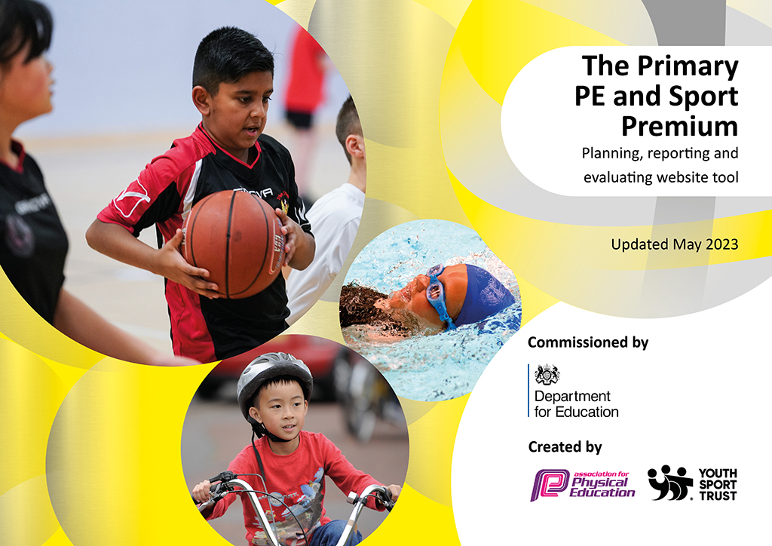
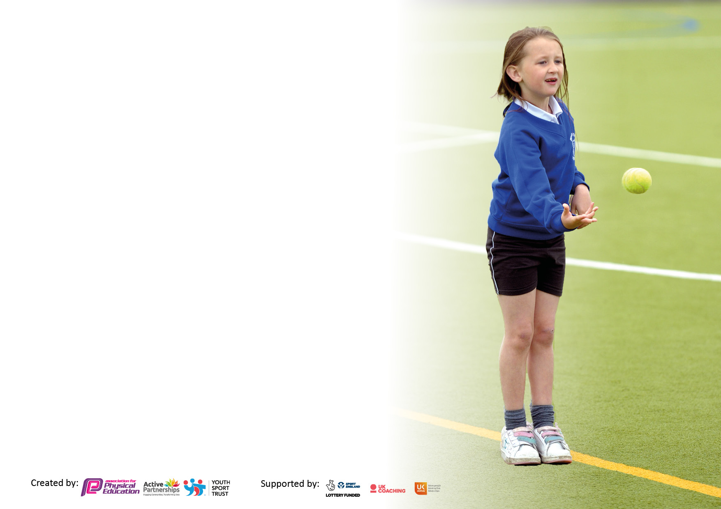

It is important that your grant is used effectively and based on school need. The Education Inspection Framework makes clear there will be a focus on ‘whether leaders and those responsible for governors all understand their respective roles and perform these in a way that enhances the effectiveness of the school’.

Under the Quality of Education Ofsted inspectors consider:
Intent - Curriculum design, coverage and appropriateness
Implementation - Curriculum delivery, Teaching (pedagogy) and Assessment
Impact - Attainment and progress

To assist schools with common transferable language this template has been developed to utilise the same three headings which should make your plans easily transferable between working documents.

Schools must use the funding to make additional and sustainable improvements to the quality of Physical Education, School Sport and Physical Activity (PESSPA) they offer. This means that you should use the Primary PE and sport premium to:

- Develop or add to the PESSPA activities that your school already offer
- Build capacity and capability within the school to ensure that improvements made now will benefit pupils joining the school in future years
- The Primary PE and sport premium should not be used to fund capital spend projects; the school’s budget should fund these.

Pleasevisitgov.ukfortherevisedDfEguidanceincludingthe5keyindicatorsacrosswhichschoolsshoulddemonstrate animprovement.Thisdocumentwillhelpyoutoreviewyourprovisionandtoreportyourspend.DfEencouragesschools to use this template as an effective way of meeting the reporting requirements of the Primary PE and Sport Premium.

We recommend you start by reflecting on the impact of current provision and reviewing the previous spend.

Schools are required to publish details of how they spend this funding, including any under-spend from 2021/2022, as well as on the impact it has on pupils’ PE and sport participation and attainment. All funding must be spent by 31st July 2023.

We recommend regularly updating the table and publishing it on your website throughout the year. This evidences your ongoing self-evaluation of how you are using the funding to secure maximum, sustainable impact. Final copy must be posted on your website by the end of the academic year and no later than the 31st July 2023. To see an example of how to complete the table please click HERE.

Details with regard to funding
Please complete the table below.

How much (if any) do you intend to carry over from this total fund into 2023/24? | £ 2883.45
Total amount allocated for 2022/23 | £ 19,530.00
Total amount of funding for 2023/23. To be spent and reported on by 31st July 2023. | £ 19,530.00
Swimming Data
Please report on your Swimming Data below.

Meeting national curriculum requirements for swimming and water safety.

N.B. Complete this section to your best ability. For example you might have practised safe self-rescue techniques on dry land which you can then transfer to the pool when school swimming restarts.
Due to exceptional circumstances priority should be given to ensuring that pupils can perform safe self rescue even if they do not fully meet the first two requirements of the NC programme of study
What percentage of your current Year 6 cohort swim competently, confidently and proficiently over a distance of at least 25 metres?  N.B. Even though your pupils may swim in another year please report on their attainment on leaving primary school at the end of the summer term 2022.  Please see note above | 22%
What percentage of your current Year 6 cohort use a range of strokes effectively [for example, front crawl, backstroke and breaststroke]?  Please see note above | 18%
What percentage of your current Year 6 cohort perform safe self-rescue in different water-based situations? | 12%
Schools can choose to use the Primary PE and sport premium to provide additional provision for swimming but this must be for activity over and above the national curriculum requirements. Have you used it in this way? | Yes/No

Action Plan and Budget Tracking
Capture your intended annual spend against the 5 key indicators. Clarify the success criteria and evidence of impact that you intend to measure to evaluate for pupils today and for the future.

Academic Year: 2022/23 | Total fund allocated: | Date Updated:
Key indicator 1: The engagement of all pupils in regular physical activity – Chief Medical Officers guidelines recommend that primary school pupils undertake at least 30 minutes of physical activity a day in school |  |  |  | Percentage of total allocation:
 |  |  |  | %
Intent | Implementation |  | Impact
Your school focus should be clear what you want the pupils to know and be able to do and about  what they need to learn and to  consolidate through practice: | Make sure your actions to achieve are linked to your intentions: | Funding allocated: | Evidence of impact: what do pupils now know and what can they now do? What has changed?: | Sustainability and suggested next steps:
To provide additional outdoor equipment so all children have access to different sports and games at break and lunch times.  To provide additional resources for PE lessons, providing children with more opportunity to engage in different sporting activities. | Consult with teachers and lunchtime supervisors about equipment that is needed at break and lunch times. Gain pupils voice to cater to their interests.  These resources are to be used by the children so that the children can participate in social sport challenges whilst outside at break times and lunchtimes and to enhance the governments active 30 challenge.  Increased level of positive behavior at lunch and break times.  New PE equipment is to be used to teach new PE skills and games to the children, such as key athletic skills. Increase level of participation and engagement in lessons.  Subject lead to audit the PE stock. And Play time resources.  Subject lead to use audit and Get Set 4 PE Scheme to determine what it necessary to deliver our PE scheme effectively. | £ 5000  Spent: £9611.84 | Equipment has been purchased and children have engaged in more active play times, children are showing greater skills in basketball, football and skipping. There are less incidents and more children are physically engaged.  90% of children have stated they enjoy their new resources with 64% of children stating they feel more active now due to the new resources.  Resources are stored and secured in a safe PE shed with school council appointed the year group monitor to ensure safe return of equipment.  Staff are well prepared with resources for every lesson. Children are highly engaged and participate in all learning, using resources available that are suitable to their needs and abilities  Children are taking part and engaging in more sporting activities. | Staff to ensure the safe use of equipment it paramount and that children are using it in the correct spaces to ensure no resources are misplaced.  Appointed sports council and play leaders to ensure they are maintaining the standard for storage to ensure longevity of resources.  Ensure play leaders are taught how to use equipment and to use it to engage as many children as possible in a wider range of activities to maintain their 60 minutes per day activity.  Resources are stored within a safe and easily accessible PE cupboard. They are to be well maintained and PE lead to continue to audit resources to ensure children have enough to learn new skills safely and fairly.
Key indicator 2: The profile of PESSPA being raised across the school as a tool for whole school improvement |  |  |  | Percentage of total allocation:
 |  |  |  | %
Intent | Implementation |  | Impact
Your school focus should be clear what you want the pupils to know and be able to do and about  what they need to learn and to  consolidate through practice: | Make sure your actions to achieve are linked to your intentions: | Funding allocated: | Evidence of impact: what do pupils now know and what can they now do? What has changed?: | Sustainability and suggested next steps:
Visitors to attend our school and engage children in workshops  Provide a broad and balanced curriculum which incorporates fitness, sports/games and swimming.  Cross-Curricular Orienteering to be set up and implemented in school. Launch day and Electrical timing days.  Raise the profile of the student Sport’s leaders by showing any sports visitors we have around the school.  Celebrate sports based achievement within school.  Increasing the number of competitive events that the school participates in both in house and outer school competitions.  After school clubs | Promote and encourage different sporting activities, share their experiences and entice children to engage in sporting activities.  A.Dynamo Cricket Club  B.Temple Martial Arts  C.Sports For Champion Visit  D.Dan The Skipping Man  Give children the opportunity to play games and sports at break times and lunch times.  Results and achievements to posted on the school social media and put into the newsletter and celebrated in class.  Advertise school sports events on social media and newsletter. | £5000  Spent: £5,465.00  £4,704.00 (C-CO) Included in the above funding. | Children are actively engaging in cricket during break times and lunchtimes. Pupil concentration, commitment, self-esteem and behaviour enhanced during lessons, break times and lunch times.  Children have been active in their role and showed visitors around school as well as providing children with a range of different games to play. | To work with another GB athlete during 2023-2024. To continue to promote local and national events by requesting assemblies and workshops to be delivered by external companies.  New Sports leaders to be appointed to allow more children the experience and share their skills. Newly appointed play leaders.

Key indicator 3: Increased confidence, knowledge and skills of all staff in teaching PE and sport |  |  |  | Percentage of total allocation:
 |  |  |  | %
Intent | Implementation |  | Impact
Your school focus should be clear | Make sure your actions to | Funding | Evidence of impact: what do | Sustainability and suggested
what you want the pupils to know | achieve are linked to your | allocated: | pupils now know and what | next steps:
and be able to do and about | intentions: |  | can they now do? What has
what they need to learn and to |  |  | changed?:
consolidate through practice:
PE lead to trial and ensure that all staff are confident with accessing lessons/progression etc. Provide staff with adaptable lesson plans and CPD.  Increase high quality PE teaching and learning throughout the whole school.  Improve assessment knowledge of all staff through input from PE lead.  Up-skill by utilizing online training and staff workshops and opportunities to attend accredited courses.  Purchase laptop for use during PE. | PE Lead to subscribe to Get Set 4 PE for one year.  Staff to use Get Set 4 PE to continue to develop their confidence and knowledge when delivering and assessing. Staff have access to online CPD, progressions etc.  Provide staff with CPD – via Get Set 4 PE and external companies to attend school - Cross-Curricular Orienteering.  Assessment support and CPD videos available.  Laptop to be used to upskill teachers knowledge and staff, ensure that they can access videos and CPD – this will be used during lessons to demonstrate to the children the correct techniques etc. including the scheme of works music and videos for dance etc. | £550  Spent £550  Linked in KI 2(C-CO)  £500  Spent £513.58 | 67% of staff agree that Get Set 4 PE prepares them for delivering PE lessons, whilst a further 33% strongly agree. 75% of staff agree that the resources have reduced work load due to knowing and understanding where to access planning and further resources. Further to this 67% of staff agree that they now know where key skills they have taught can be applied in other PE units either in the current year group or beyond.  75% of staff are more confident in delivering PE.  Staff have been supported with online CPD for assessment and have been supported by subject lead to assess using formative assessment, this is now used across all year groups. Data is easily accessible and staff have stated it has not increased their work load. Subject lead will use this to prepare next academic year’s curriculum coverage.  Less disruption during lessons due to faster working technology, ensuring children are engaged quicker. The children are able to watch other children model the skills accurately, addressing any misconceptions children/staff have ensuring techniques and skills are taught correctly. Music and videos are all accessed via the laptop.  Staff have access to CPD through a shared computer and are able to deliver appropriate, progressive lessons. | Continue with Get Set 4 PE subscription to continue to support the delivery of PE.  Staff to receive CPD on subject specific skills/sports.  No further next steps necessary.
Key indicator 4: Broader experience of a range of sports and activities offered to all pupils |  |  |  | Percentage of total allocation:
Intent | Implementation |  | Impact
Your school focus should be clear | Make sure your actions to | Funding | Evidence of impact: what do | Sustainability and suggested
what you want the pupils to know | achieve are linked to your | allocated: | pupils now know and what | next steps:
and be able to do and about | intentions: |  | can they now do? What has
what they need to learn and to |  |  | changed?:
consolidate through practice:
Cross-Curricular Orienteering offered to all pupils from Nursery to year 6.  Provide children with afterschool club provision.  Additional achievements: | Staff will be trained to deliver highly engaging orienteering across the whole curricular, they will deliver this via carefully mapped out school, with progressive lesson plans for children from Nursery to year 6. Encouraging more active learning and achieving 60 minutes physical activity.  Through student voice it was evident that children would like an afterschool club that promotes dance and gymnastics. We will seek a local gymnastics club to deliver after school sessions. | Linked in KI 2(C-CO)  £1200  Spent:£1000 | Due to Birmingham movement of transition days, orienteering launch day has been postponed to the Autumn Term, ensuring our children are engaged and ready for it to be implemented appropriately into the school timetable.  Dazzlers Dance School deliver weekly after school clubs, they have worked with a range of year groups. 98% of children have stated they enjoyed the club and 90% would like it to continue in the next academic year. | Cost of the following year is dramatically reduced to £400 per year. Sign up to multiple years to ensure staff are confident in their teaching and resources are accessible.  CCO will deliver another experience day in Spring term 2024.  Staff have received CPD during this and can deliver; alternatively reach out to parents to pay a small amount to ensure the club can still run.

Key indicator 5: Increased participation in competitive sport |  |  |  | Percentage of total allocation:
 |  |  |  | %
Intent | Implementation |  | Impact
Your school focus should be clear | Make sure your actions to | Funding | Evidence of impact: what do | Sustainability and suggested
what you want the pupils to know | achieve are linked to your | allocated: | pupils now know and what | next steps:
and be able to do and about | intentions: |  | can they now do? What has
what they need to learn and to |  |  | changed?:
consolidate through practice:
Ensuring as many children as possible have the opportunity to compete in sports against other schools.  Children to engage in competitive sports against their peers, with parents present. | Re-registering to ESPSFA football league so children can compete against other schools  Attending a variety of sporting events to including: school games competitions such as multi-skills, all year groups can attend.  Sports Day Events | £500  Spent £450  £2000  Spent:  £2100 | Children have attended competitive tournaments outside of school, against other school children from the local area. | Children to partake in more competitive sporting activities, looking at joining netball and dodgeball, archery etc.

Signed off by
Head Teacher: | PHiggins
Date: | 25/07/2023
Subject Leader: | Ashleigh Wilson
Date: | 25.07.2023

