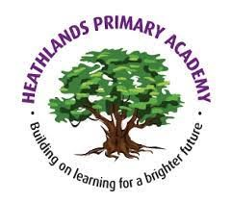
Useful websites
· www.phonicsplay.co.uk
· www.primaryresources.co.uk
· Phonics RWI: https://www.ruthmiskin.com/en/find-out-more/parents/
· Youtube: days of the week song, months of the year song, seasons of the year song, 2D shape song.

Summer 1:
‘Paws, Claws and Whiskers’

A note from Year 1 Staff
We are really excited to start our new topic ‘Paws, Claws and Whiskers’. Just a reminder to please ensure your child is reading their home reader book and returning it (diary signed by a parent/carer) every day to get a new book every Monday. Please also help your child to practise reading their tricky words sheet that is sent home.
PE lessons will take place every Monday (1OP) and Tuesday (1D) and we ask that children are sent to school wearing their PE kits on this day each week.
Best wishes, Year 1 Team
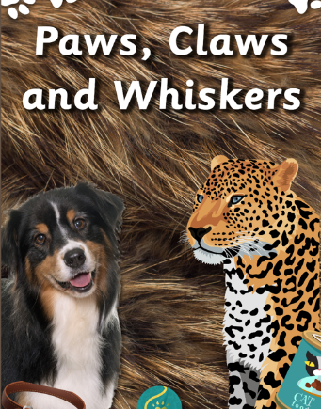
Topic for Summer 1 - ‘Paws, Claws and Whiskers’

Soft fur, sharp claws and twitching whiskers. What’s your favourite animal? One that meows? One that barks? Or maybe one that scurries or slithers?
Reminder: Please ensure your child comes to school with a water bottle that is clearly labelled with their name and that all clothing is clearly labelled – Thanks.

From pets at home to animals in the zoo, let’s find out what animals like to eat and where they like to sleep. Do you know how to look after a rabbit? A cat? Or even a snake? Who is a herbivore and who is a carnivore?
Science
In this unit about ‘Animals Including Humans,’ children will learn about five of the groups that scientists use to classify animals: mammals, fish, birds, reptiles and amphibians. They will learn to identify the group an animal belongs to by its features and will classify animals according to their group. They will also learn about the different diets animals eat. Children will learn about the parts of the human body and have the opportunity to explore the five senses through a simple investigation. In the final lesson, children will use all their knowledge from this unit to classify animals according to their own criteria.

Maths

This half term will focus on:
- Mass and volume
- Multiplication and division
- Fractions

We will learn about capacity and volume through practical and paper-based lessons. The children will use a variety of maths equipment to help them get a better understanding of counting in 2s, 5s and 10s.

English
In English we will be looking at information texts about how to look after a pet. We will also be reading the classic tale of ‘The Tiger Who Came to Tea’. We will learn the story by heart and then ‘innovate’ it by changing aspects of the story such as the characters. Work on sentences will continue, especially the use of capital letters, finger spaces and full stops. Question marks and exclamations marks will also be revised. We will also be learning the Year 1 common exception words. We will also continue with our daily phonics lessons.
Music

Our Music this half term celebrates a wide range of musical styles. The children will be Listening, Singing, Playing Composing and Performing.
Computing

In Computing, the children will be looking at the topic of ‘Simple Algorithms and Programs’. The unit will begin with unplugged sessions where the children will look at the importance of simple algorithms and ‘debugging’ any mistakes they may contain. This will then move on to using programmable toys – ‘BeeBots’ – to plan routes using simple algorithms.
RE

The theme for this half terms RE is ‘Shabbat’ and the key question we will be looking at is “Is Shabbat important to Jewish children?”

Art
In Art, children are introduced to the idea that many artists use flora and fauna to inspire their work. We look at artists who used drawing as a way to accurately capture the way plants and insects look, and artists who use their imagination to create their own versions of flora and fauna.

Humanities

Our Humanities this half term will mostly be Geography based. We will continue to learn about the seven continents and five oceans of the world. Maps of where different animals can be found will be looked at and why certain animals live where they live.
P.E.
Pupils develop the basic skills required in invasion games such as sending, receiving and dribbling a ball. They develop their understanding of attacking and defending and what being 'in possession' means. They have the opportunity to play uneven and even sided games. They learn how to score points in these types of games and how to play to the rules. They work independently, with a partner and in a small group and begin to self-manage their own games, showing respect and kindness towards their teammates and opponents.

